Content

Android Version Required

You

Compiling and Deploying Environment

You

Main Function

1. layout截图

2. 粗略描述所有功能， 贴小图标

3. 详细描述单个功能

3.0 MainActivity

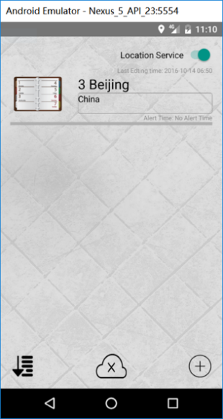

After users login with their Facebook accounts, they will get into this activity. In this activity, users can see the notes they save in the phone. They can add new notes with the Add New Note Button, sort the notes with the Sort Button, logout Facebook with the Logout Button and open or close the background location check service with the Location Service Switch. The layout of the MainActivity is shown below.

3.1 Location Service Switch



If this switch is set on, the location notification service will run in the background.

If it is set off, there will be no notification based on the alert location when users close the app.

3.2 Sort Button



After clicking on the sort button, there will be two options displayed. The default sort order is LAST EDITED TIME. If users click on the SORT BY LOCATION, the notes will be sorted by the alert location.

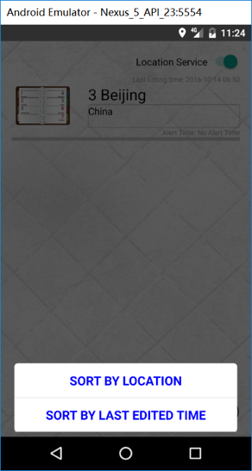

3.3 Logout Button



After clicking on this button, users will logout of their Facebook accounts and return to the login page.

3.4 Add New Button



By clicking on this button, user can start to add a new note in the edit page.

3.5 Short click on the note

By short clicking on the note, users can edit the note clicked in the edit page.

3.6 Long click on the note

By long clicking on the note, there will be a dialog that pops up.

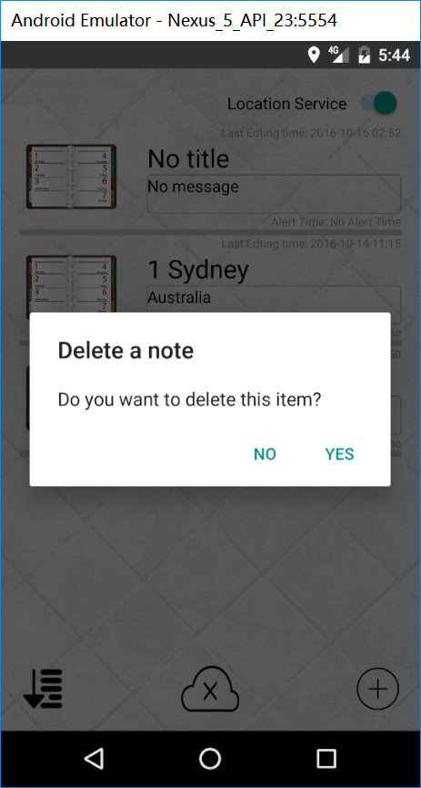

If users click on YES, the long clicked note will be deleted. If NO is clicked, the dialog will be closed and the note will also not be deleted.

5.0MapsActivity

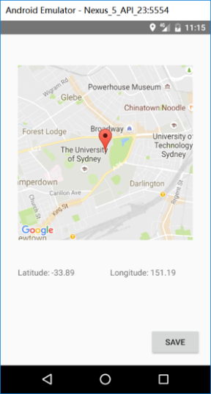

After clicking on the set alert location button, this App will jump to this activity, the layout is shown above. A google map will be shown in this activity. Users can set the alert location here.

5.1 Drag the Marker

drag the marker to set the alert location.

5.2 Click on the Map

Users can also click on the map, the marker will be moved to that place automatically.

5.3 Save Button

Troubleshooting

Problem: I can not get the location based note notification.

- Make sure the Location service switch  is set to on.

- Make sure that the location is saved correctly like this: .

- Make sure your phone allows app to access to the location information.

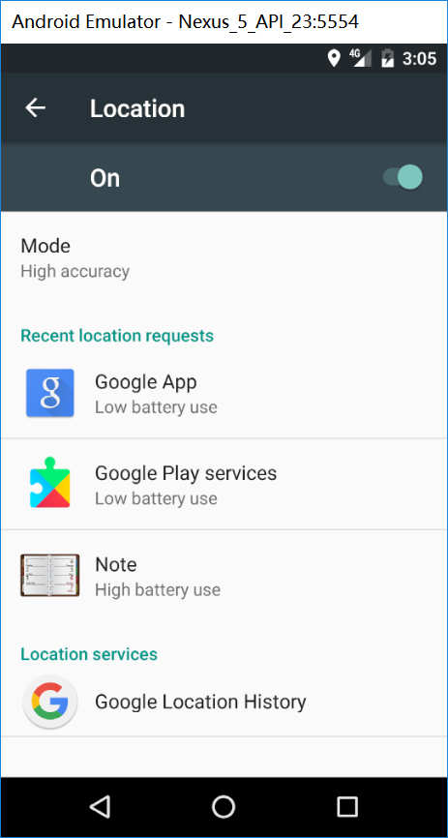

- Make sure your phone allows NOTE to send notification.

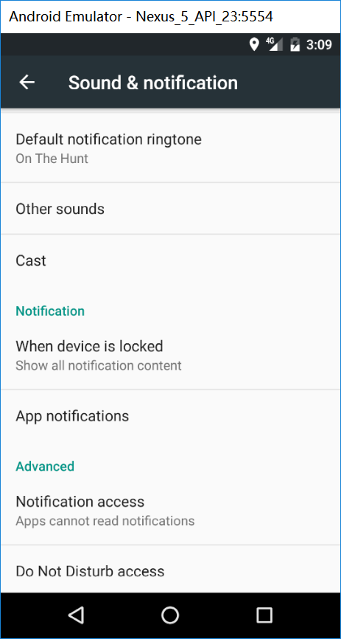

- If you set the alert location as your current location, you can not receive the notification immediately. You should walk 100 meters away from the current location first. After walking back to that location, you can receive the notification.

- If you have turned off the power of your phone, after starting the phone, you should open NOTE again. The location notification background service can not start automatically at the booting of the phone. This function will added in the following version of this App.